# Assignment 2 Template

# Alexander Patapan, 44792925

**SCREENSHOT OF DESIGNER VIEW FROM PHPMYADMIN (You may put this in sideways if required)**

­­­­­ 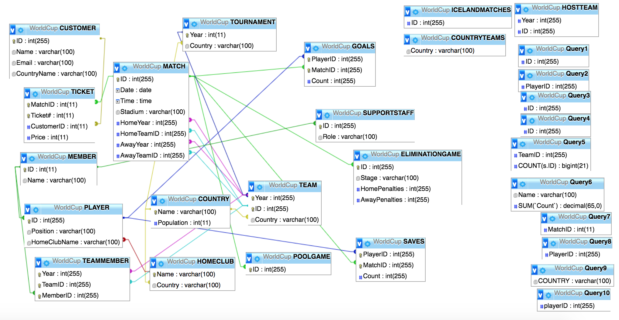

Query 1: Find all the Australian Players that played in the 2018 World Cup

QUERY SQL

Assumption: If a player has played in a match, they received a GOAL and SAVE score of 0. It is possible to be on a team and not play in any matches.

CREATE VIEW Query1 as

SELECT distinct ID

FROM PLAYER, TEAMMEMBER

WHERE ID = MemberID AND Year = 2018 AND ID in (SELECT PlayerID

FROM GOALS, `MATCH`

WHERE MatchID = ID AND YEAR(DATE) = 2018)

AND (TeamID IN (

SELECT t.ID

FROM TEAM t, `MATCH`

WHERE Country = 'Australia' and HomeTeamID = t.ID AND HomeYear = 2018)

OR TeamID IN (

SELECT t.ID

FROM TEAM t, `MATCH`

WHERE Country = 'Australia' and AwayTeamID = t.ID AND AwayYear = 2018))

QUERY OUTPUT (SCREENSHOT)

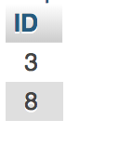

Query 2: Find the players that have never scored a goal

QUERY SQL

Assumption: A player who has never played a game has never scored a goal

CREATE VIEW Query2 as

SELECT ID

FROM PLAYER

WHERE (ID in (

SELECT PlayerID

FROM GOALS

GROUP BY PlayerID

HAVING SUM(Count) = 0)) or (ID NOT IN (SELECT PlayerID FROM GOALS))

QUERY OUTPUT (SCREENSHOT)

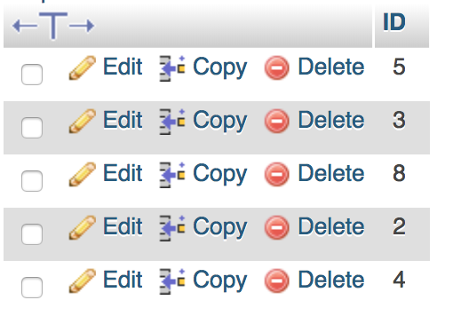

Query 3: Find all the pool games played by host countries

QUERY SQL

Assumption/ Clarification: A host country can be an away team

CREATE VIEW HOSTTEAM(Year, ID) as

SELECT t.Year, ID

FROM TEAM t, TOURNAMENT tou

WHERE t.Country = tou.Country AND t.Year = tou.Year;

CREATE VIEW Query3 as

SELECT DISTINCT m.ID

FROM `MATCH` m, POOLGAME pg, HOSTTEAM ht

WHERE m.ID = pg.ID and ((HomeTeamID = ht.ID and HomeYear = ht.Year) or (AwayTeamID = ht.ID and AwayYear = ht.Year))

QUERY OUTPUT (SCREENSHOT)

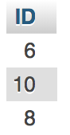

Query 4: Find all the Australian players linked to an English club team

QUERY SQL

Assumption: An Australian player is anyone who has ever been on an Australian team.

CREATE VIEW Query4 as

SELECT DISTINCT p.ID

FROM PLAYER p, TEAMMEMBER tm, TEAM t

WHERE p.ID = tm.MemberID AND tm.TeamID = t.ID AND tm.Year = t.Year AND Country = 'Australia' AND HomeClubName IN(

SELECT Name

FROM HOMECLUB

WHERE Country = 'England')

QUERY OUTPUT (SCREENSHOT)

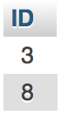

Query 5: Rank the teams by the number of support staff attending the 2018 World Cup

QUERY SQL

Assumption: Teams with no support staff are still included in list

CREATE VIEW SUPPORTTEAMS2018(MemberID, TeamID) as

SELECT ID, TeamID

FROM TEAMMEMBER, SUPPORTSTAFF

WHERE MemberID = ID;

CREATE VIEW Query5 as

SELECT ID, COUNT(MemberID)

FROM TEAM LEFT JOIN SUPPORTTEAMS2018 ON TeamID = ID

WHERE Year=2018

GROUP BY ID

ORDER BY COUNT(MemberID) DESC

QUERY OUTPUT (SCREENSHOT)

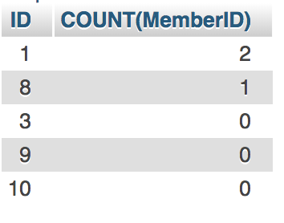

Query 6: Find the names & number of goals saved by all players

QUERY SQL

Clarification of Logic/ Assumption: If a player has played in a match, they received a GOAL and SAVE score of 0. A player who has never played in a game will not be in the SAVES table, yet will have also have never saved a goal.

CREATE View Query6 as

SELECT Name, IFNULL(SUM(`Count`),0)

FROM MEMBER LEFT JOIN SAVES ON ID = PlayerID

WHERE ID in (SELECT ID FROM PLAYER)

GROUP BY ID

QUERY OUTPUT (SCREENSHOT)

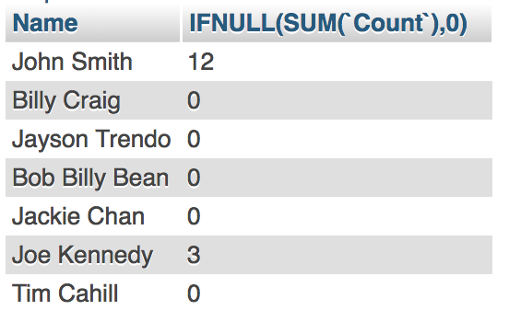

Query 7: Find the game that sold the most tickets

QUERY SQL

CREATE VIEW Query7 as

SELECT MatchID

FROM TICKET

GROUP BY MatchID

HAVING COUNT(*) >= all (

SELECT COUNT(*)

FROM TICKET

GROUP BY MatchID)

QUERY OUTPUT (SCREENSHOT)

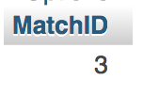

Query 8: Find the player who scored the most goals in elimination games

QUERY SQL

CREATE VIEW Query8 as

SELECT PlayerID

FROM GOALS

WHERE MatchID IN (

SELECT ID

FROM ELIMINATIONGAME)

GROUP BY PlayerID

HAVING SUM(`Count`) >= ALL(

SELECT SUM(`Count`)

FROM GOALS

WHERE MatchID IN (

SELECT ID

FROM ELIMINATIONGAME)

GROUP BY PlayerID)

QUERY OUTPUT (SCREENSHOT)

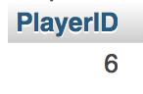

Query 9: Find countries that have played in all World Cups

QUERY SQL

Assumption: A country must have played atleast 1 match in each worldcup. Merely having a team for that year on the database is not enough to conclude they played that year

CREATE View COUNTRYTEAMS(Country) as SELECT Country

FROM TEAM t, `MATCH`

where (`Year` = HomeYear and t.ID = HomeTeamID) or (`Year` = AwayYear and t.ID = AwayTeamID)

group by t.`Year`, t.ID;

CREATE VIEW Query9 as

SELECT COUNTRY

FROM COUNTRYTEAMS

GROUP BY Country

HAVING COUNT(*) = (

SELECT COUNT(*)

FROM TOURNAMENT )

QUERY OUTPUT (SCREENSHOT)

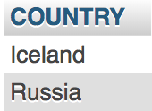

Query 10: Find players who have scored goals in all of Iceland’s games

QUERY SQL

CREATE VIEW ICELANDMATCHES(ID) as

select m.ID

from `MATCH` m, TEAM t

where ((`Year` = HomeYear and t.ID = HomeTeamID) or (`Year` = AwayYear and t.ID = AwayTeamID)) and Country = 'Iceland';

CREATE VIEW Query10 as

SELECT playerID

FROM GOALS

WHERE `count` > 0 AND MatchID IN (select ID from ICELANDMATCHES)

GROUP BY playerID

HAVING COUNT(*) = (SELECT COUNT(*)

FROM ICELANDMATCHES)

QUERY OUTPUT (SCREENSHOT)

